x=[11, 8, 5, 21, 9, 11, 5, 11, 6, 9, 21, 8, 7]

print(x)

y=[]

for i in x:

if i not in y:

y.append(i)

print(y)

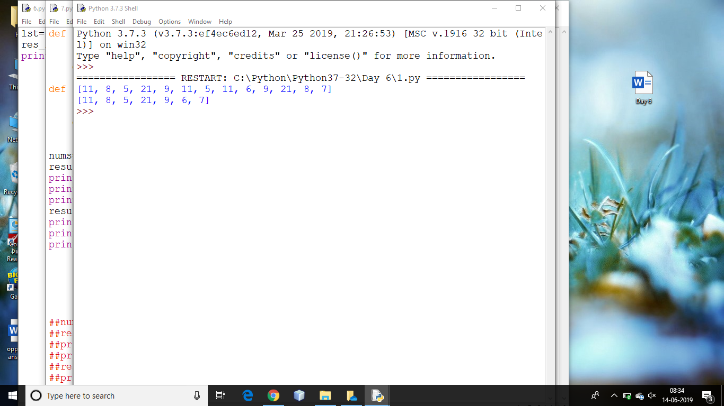

lst=[11,8,5,21,9,11,9,21,8]

print(lst)

new_set=set(lst)

lst=list(new_set)

print(lst)

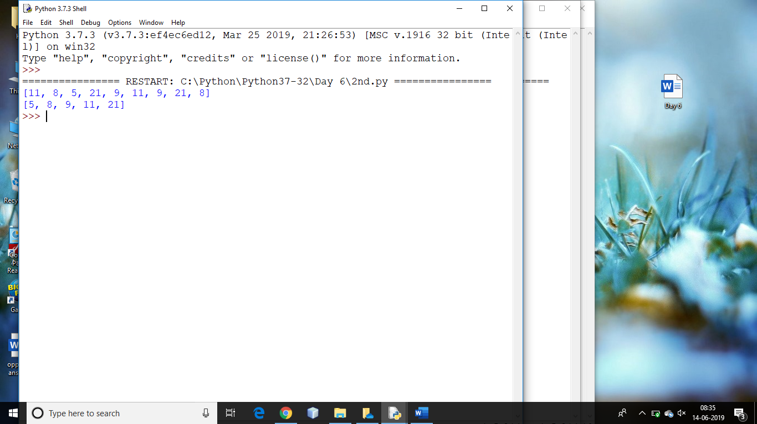

x=[2,3,4,5]

y=[-1,2,-2,1]

z=[10,20,15,30,25,67]

print('x',x)

print('y',y)

print('z',z)

res=[]

for i,j,k in zip(x,y,z):

res.append(i+j+k)

print('res',res)

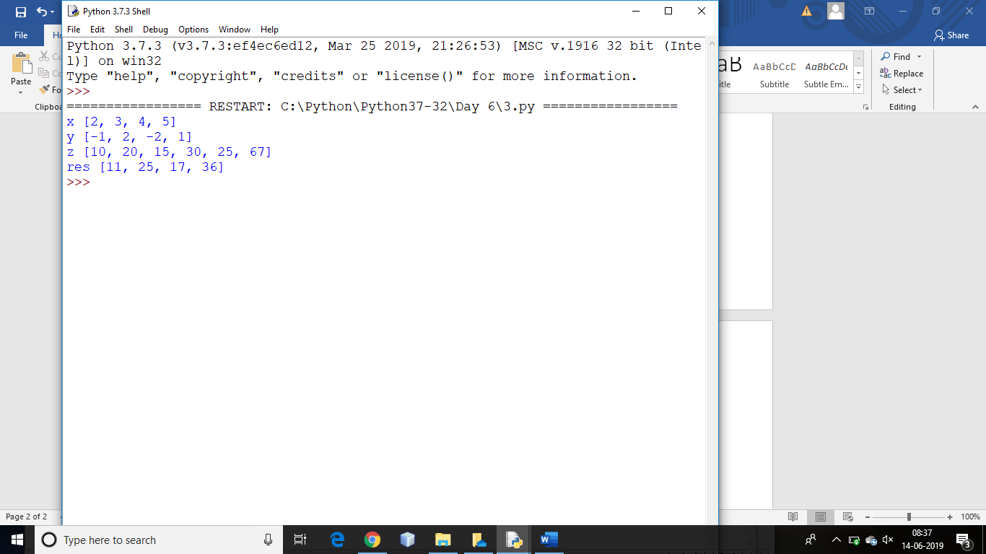

def add_five(x):

temp=x+5

return temp

nums=[11,22,33,44,55]

result=list(map(add_five,nums))

print(nums)

print(result)

print('-'*40)

num=[11,22,33,44,55]

result=list(map(lambda x:x+5,num))

print(num)

print('After use of lambda in map',result)

def cube(a):

return a*a*a

lst=[1,2,3,4,5,6,7]

res=list(map(cube,lst))

print(res)

num=[1,2,3,4,5,6,7]

result=list(map(lambda x:x*x*x,num))

print(result)

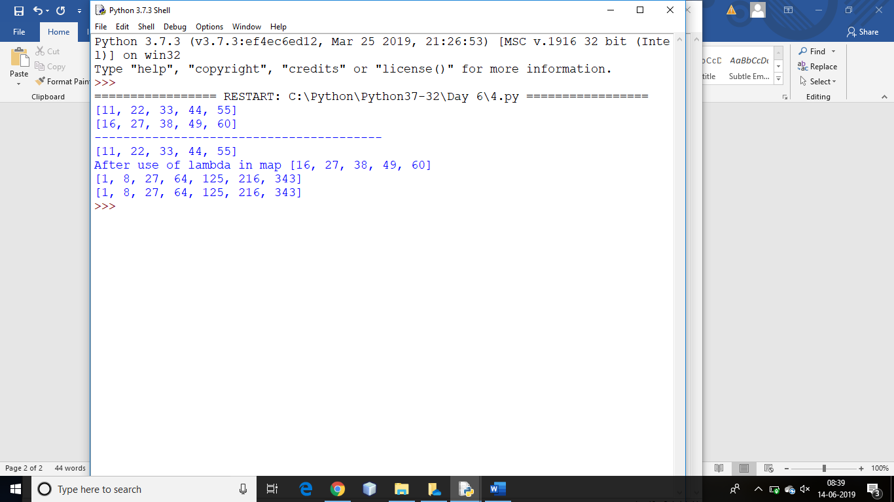

x=[1,2,3,4,5,6]

y=[10,20,30,40,50,60]

z=[11,22,33,44,55,66]

result=list(map(lambda a,b,c:a+b+c,x,y,z))

print(result)

def add(a,b,c):

return a+b+c

x=[1,2,3,4,5,6]

y=[10,20,30,40,50,60]

z=[11,22,33,44,55,66]

result=list(map(add,x,y,z))

print(result)

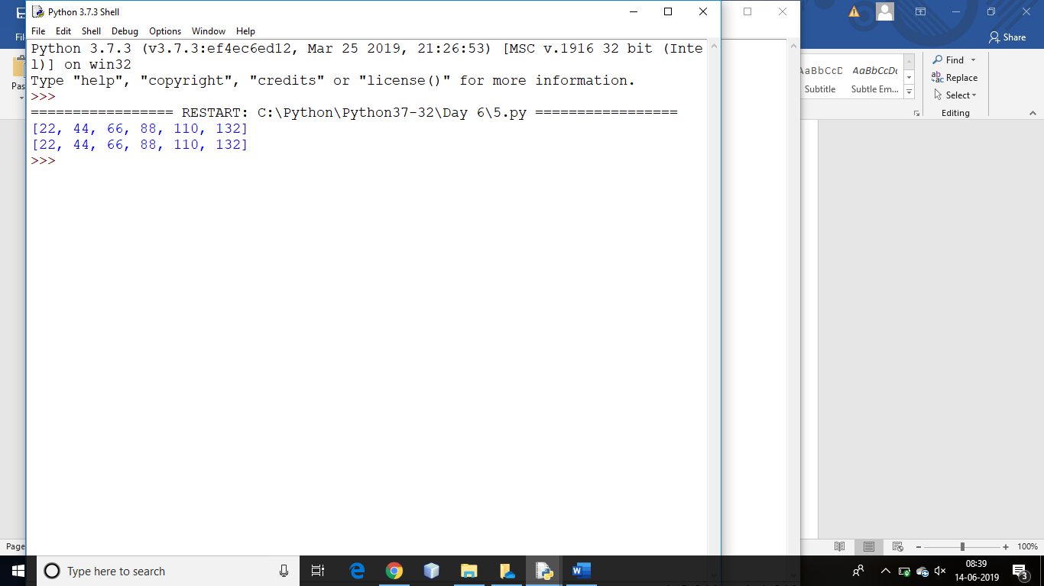

lst=['apple','mango','papaya','orange']

res_lst=list(map(len,lst))

print(res_lst)

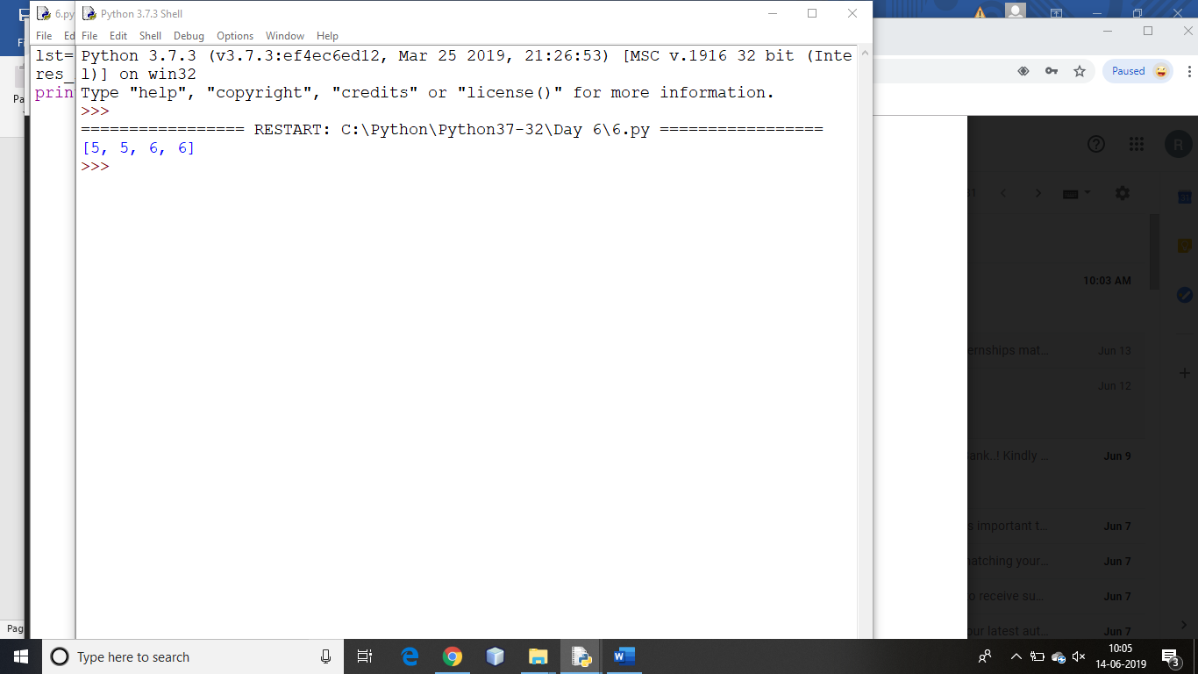

def find_odd(x):

if x%2==1:

return True

else:

return False

def find_even(x):

if x%2==0:

return True

else:

return False

nums=[11,22,33,44,55]

result=list(filter(find_odd,nums))

print(nums)

print("odd:",result)

print('-'*20)

result=list(filter(find_even,nums))

print(nums)

print("even:",result)

print('-'*20)

num=[11,22,33,44,55]

result=list(filter(lambda x:x%2==1,num))

print("odd:",result)

print('-'*20)

result=list(filter(lambda x:x%2==0,num))

print("even",result)

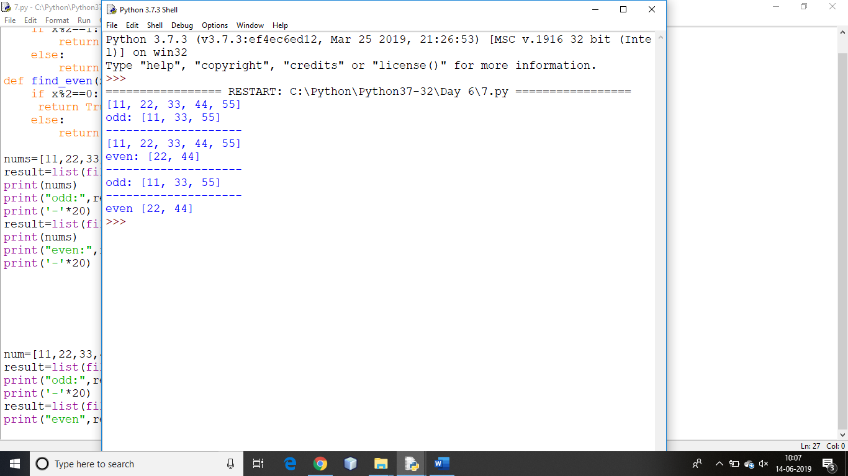

x=['python','java',88,99.9,11,'c++','pearl','ada']

def fun_str(a):

if isinstance(a,str):

return a

y=list(filter(fun_str,x))

z=list(filter(lambda a:isinstance(a,int),x))

p=list(filter(lambda a:isinstance(a,(int,float)),x))

print(y)

print(z)

print(p)

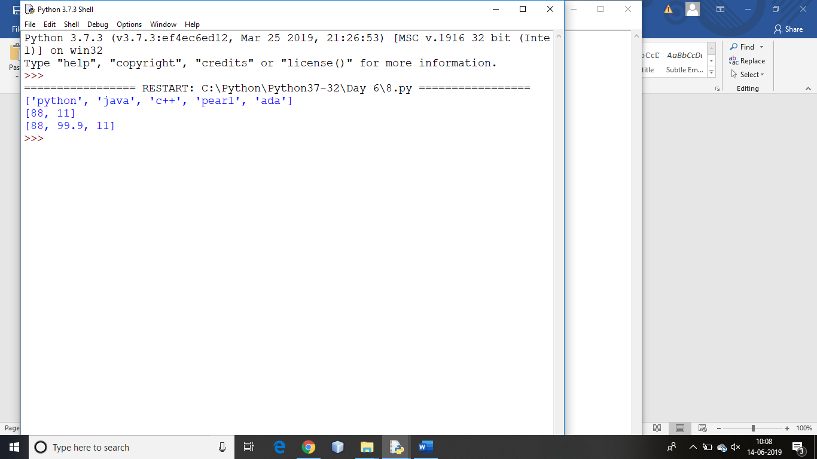

items=['egg','milk','butter','peanuts','oats','honey']

for i in enumerate(items):

print(i,end=',')

print('\n')

items=['cup','pen','book']

for i in enumerate(items,100):

print(i,end=',')

